**OBJECT ORIENTED PROGRAMMING**

**ASSIGNMENT#2**

|  |  |
| --- | --- |
| **SUBMITTED TO** | **DR SHAHID BHATTI** |
| **SUBMITTED BY** | **ABIS RAZA HAIDER** |
| **ROLL NO** | **SP24-BSE-145** |

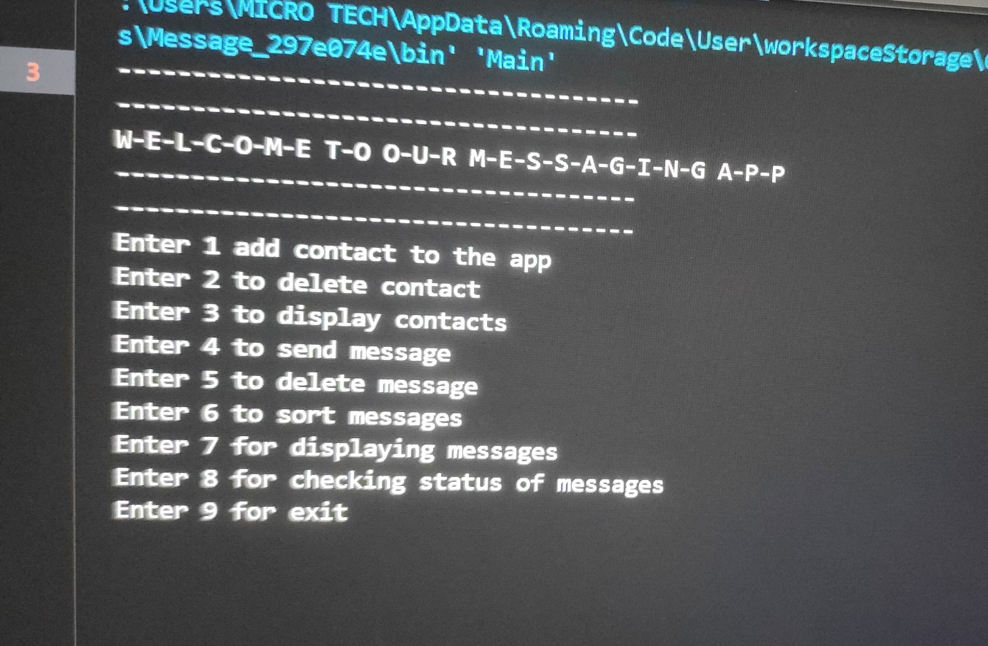

**This is the intro to messaging app. You can check my menu for the app.**

**Here I will show you linewise different functions of my app.**

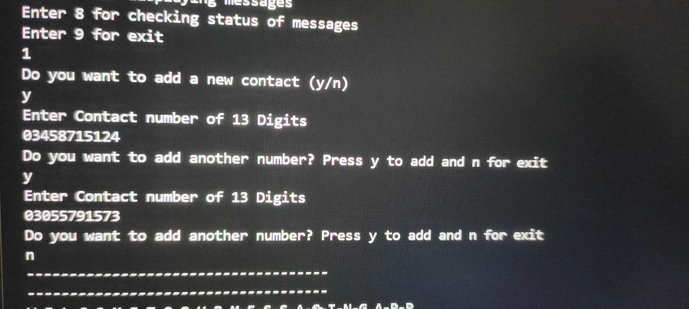

**Here you can add different contacts as I have added 2 contacts.**

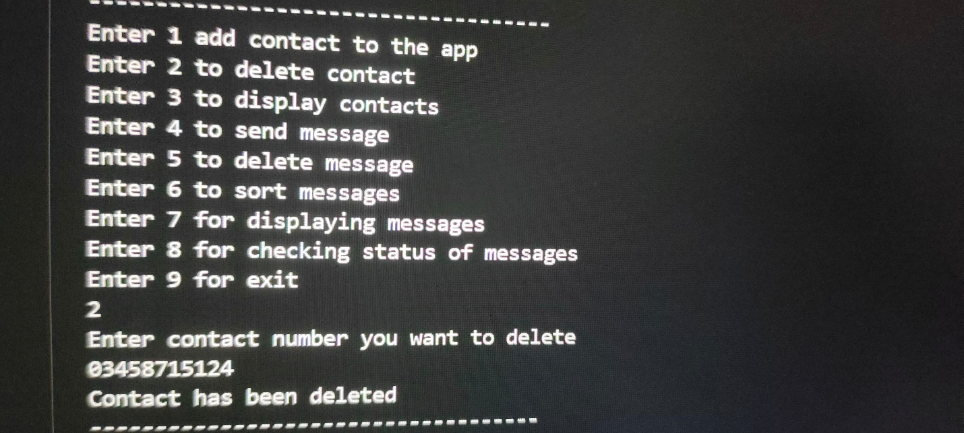

**As you can see I have a option of delete contacts in my app.**

**So u can delete your added contacts.**

**Now come to display contacts.**

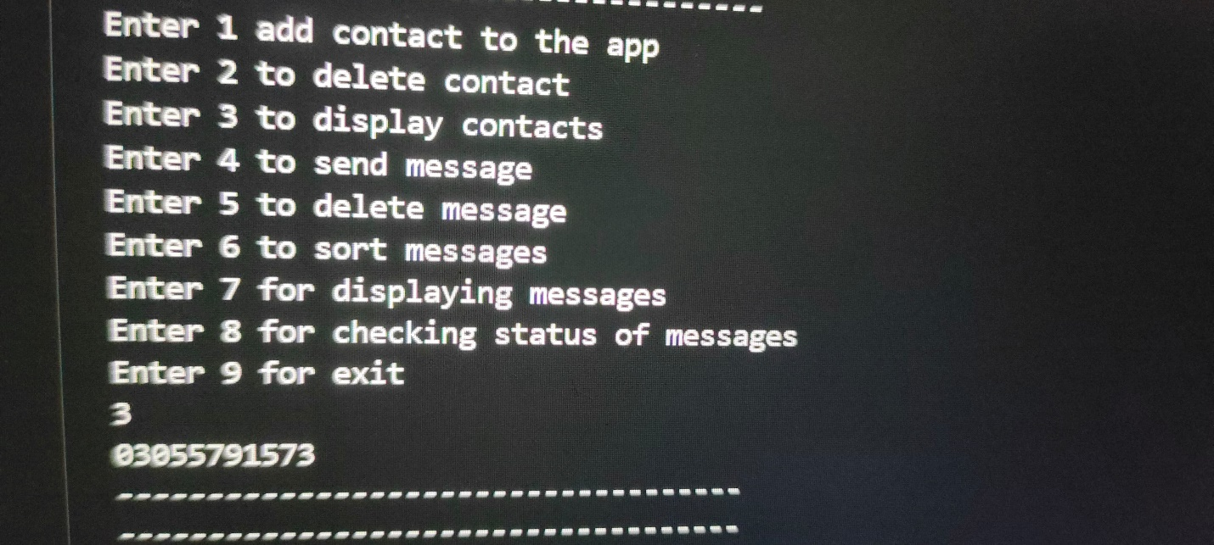

**As I added 2 contacts and deleted one of them so now I have 1 contact to show you so you can see sir my contact list.**

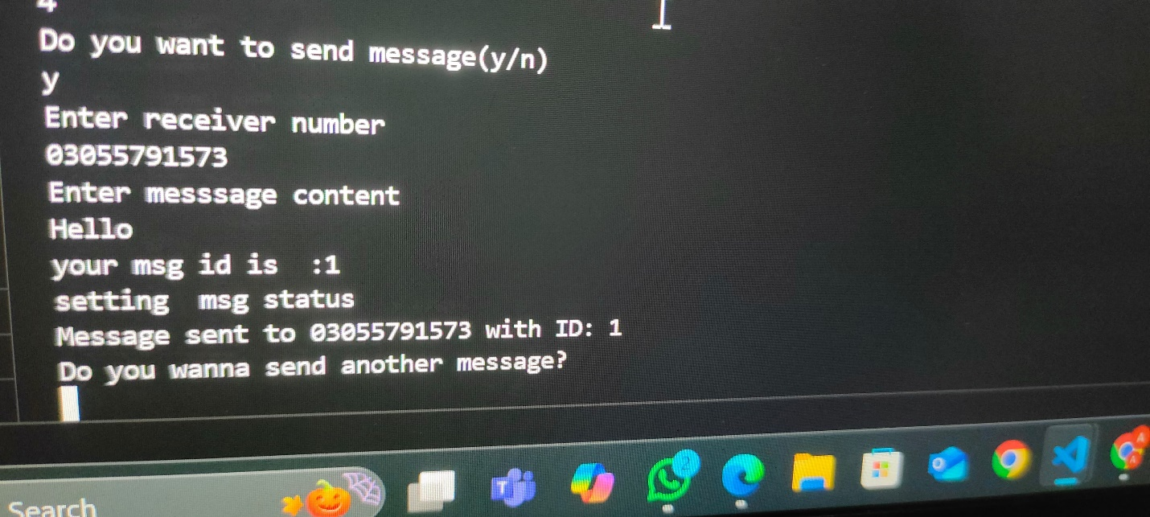

**Now I am sending message to my added contacts.**

**First this app requires whether your number is added in the list or not and then it requires my message content to send, and then I used a auto id generator for id.**

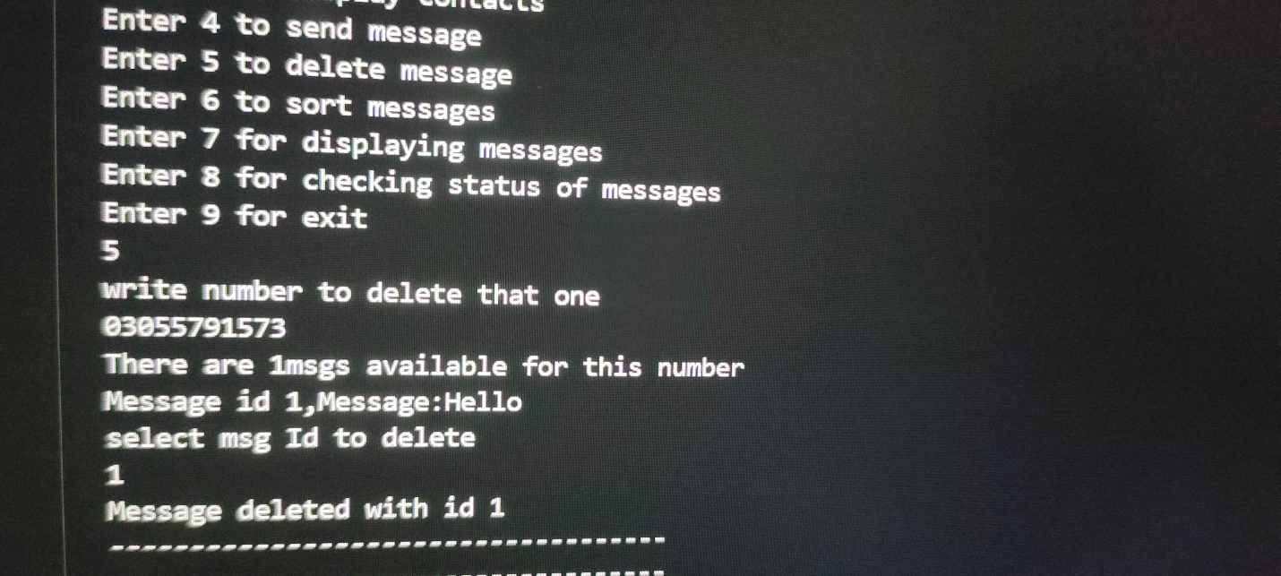

**As we can send messages we can delete these messages too. For this you have to just add your contact information and that specific id of the msg so u can delete messages easily.**

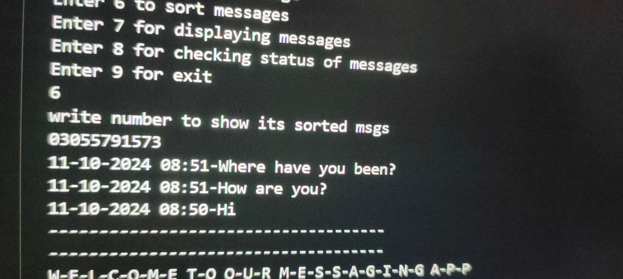

**We can also see our most recent messages with time frame.The message sent most recently is on top of list and the message sent before is on the bottom and you can see time too with date.**

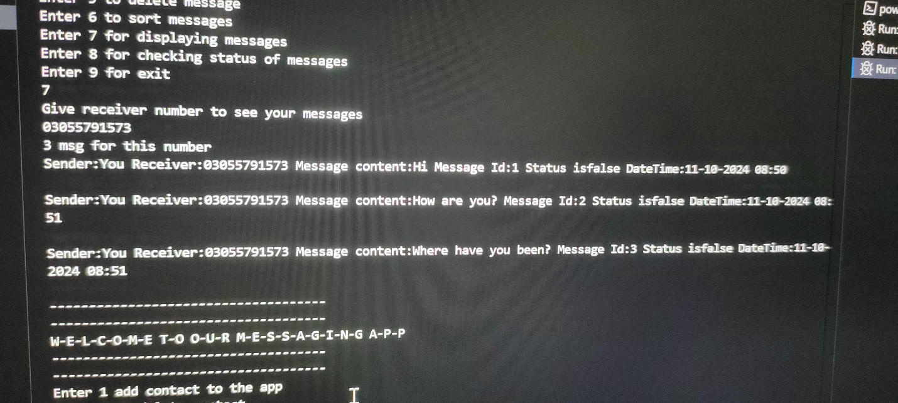

**You can also list of message I have sent to that specific receiver with message content,message id etc…**

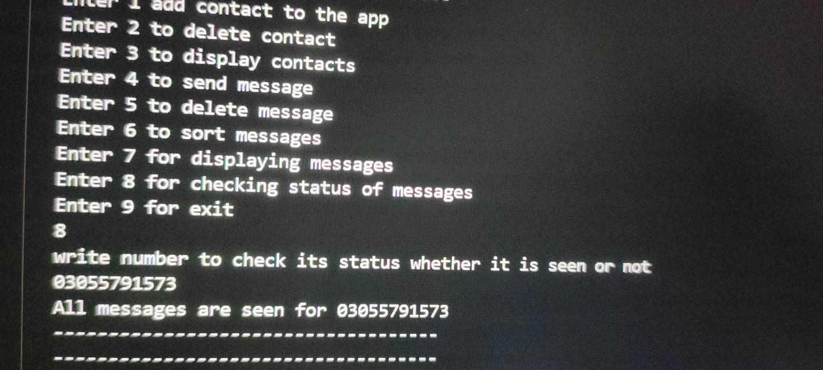

**Here we can check that we have seen messages or not. If we have seen messages it will show All messages are seen for that number otherwise it will show these messages are not seen for that number.**

**And If we press 9 then we will exit from the app.**

**That’s all from the app.**